**Part 1:**

An object oriented program (OOP) for problem a) of HW5 has been written and placed on Canvas for you to download and study.

1. Create a class for a sprinkler head that includes the k value (i.e., Qsprinkler=k⋅p1/2) for each sprinkler and find the k values for the sprinklers (nodes: b, d, f, h) for the modified pipe network shown below, where all the nodes are at the same elevation. Note: the minimum pressure head at a sprinkler is 2m of water.
2. Modify any other classes (as needed) to calculate the flows in the pipes for the modified layout of the pipe network as shown below and print your results (flow rate in each pipe, confirmation of net node inflow and net loop pressure drop). Elevation of nodes: *a*=0, b=2.5m, (c,d,e)=(5m, 5m, 5m), (f,h)=(4m, 4m) g=4.5m



65 m

10 L/s

*b*

20

**Part 2:**

Note: steam-stem.py and rankine-stem.py have been written an uploaded to Canvas for your use.

You will be writing three python files – steam.py, rankine.py and test_rankine.py used to analyze two different Rankine power cycles:

1. p_high=8000kPa, p_low=8kPa, x1=1 (i.e., saturated vapor entering turbine)
2. same as *i*) except that T1=1.7⋅ Tsat (i.e., superheated steam into the turbine).

In both cases, the turbine and pump operated isentropically.

The file test_rankine.py should import from rankine.py and instantiate two different rankine objects with the properties as specified above. The calculate the cycle efficiencies and output a report for each cycle.

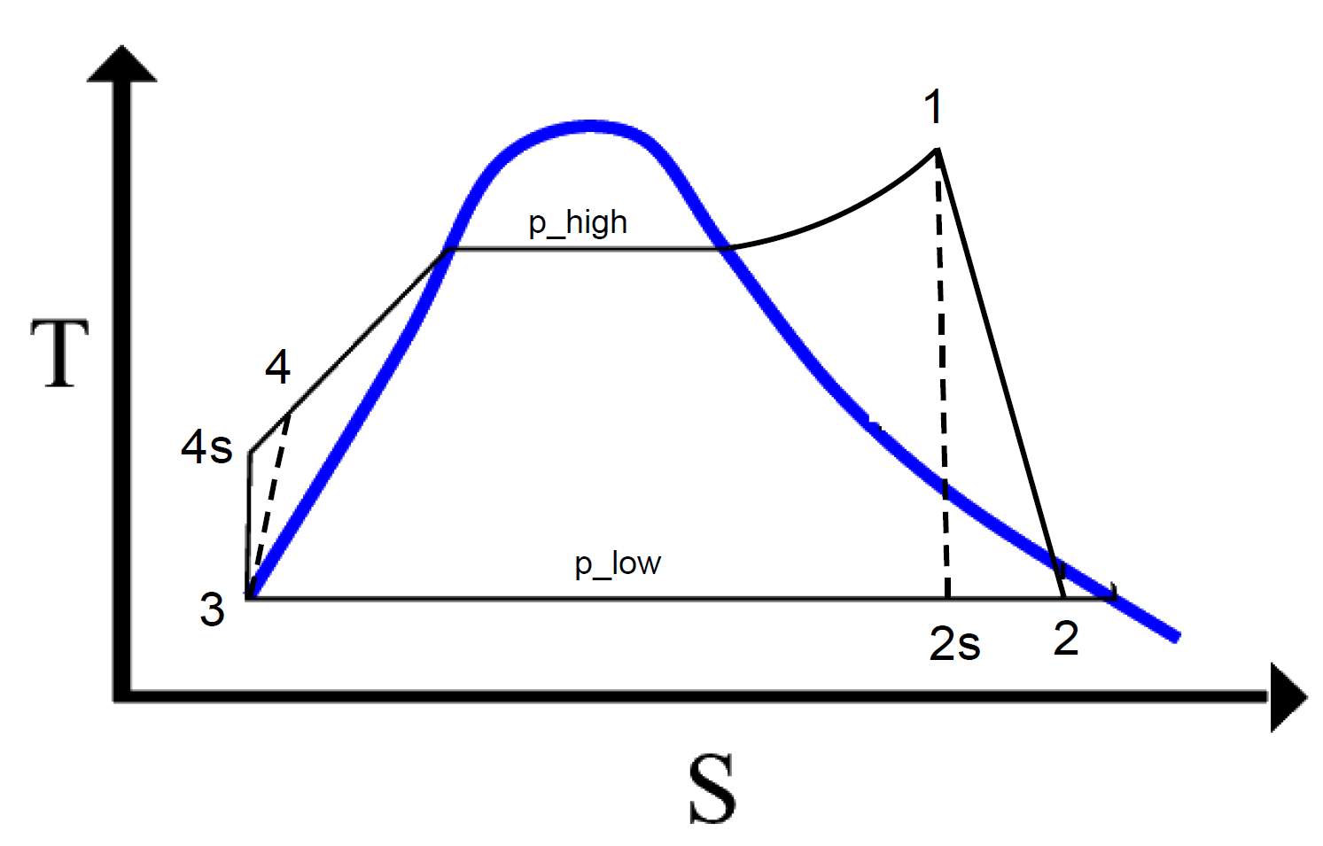

***Results printed from rankine – main()***

